**Team No: 14**

**Names: KAVIN M**

**KAVINRAJ TJ**

**KAVINRAJ E**

**Power BI Dashboard for Sales Dashboard Dataset**

**Introduction**

This dashboard provides insights into sales data over the years, segmented by various metrics such as region, customer, product profitability, and market segments. The goal is to help stakeholders analyze sales trends, identify top-performing areas, and address losses effectively.

**Project Objectives**

The primary objectives of the dashboard are to:

* Analyze the distribution of sales over the years
* Examine the sales segmentation by category
* Evaluate product performance and profitability
* Assess the regional and market-wise sales performance
* Track operational efficiency metrics

**Dashboard**

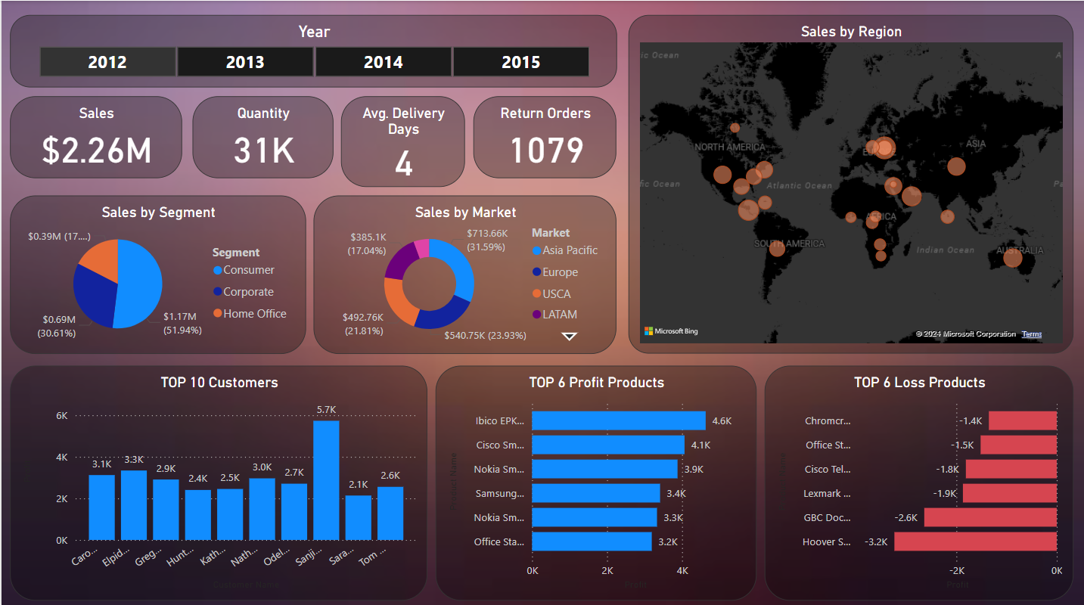

**Data Sources**

The dashboard is built using the Sales dataset, which includes information on:

* Key Performance Indicators
* Sales by Segment
* Runtime
* Sales by Market
* Sales by Region (Map Visual)
* Top 10 Customers (Bar Chart)

**Inference from Dashboard**

**1.** **Key Performance Indicators (KPIs)**

* Total Sales: $2.26M
* Total Quantity Sold: 31K
* Average Delivery Days: 4 days
* Return Orders: 1079

**2. Sales by Segment**

* Consumer: $1.17M (51.94%)
* Corporate: $0.69M (30.63%)
* Home Office: $0.39M (17.45%)

**3. Sales by Market**

* Asia Pacific: $713.66K (31.59%)
* Europe: $540.75K (23.93%)
* USCA: $492.76K (21.81%)
* LATAM: $385.1K (17.04%)

**4. Top 6 Profit Products**

* Ibico EPK: $4.6K
* Cisco Small: $4.1K
* Nokia Smart: $3.9K
* Samsung Smart: $3.4K
* Office Supplies: $3.2KM

**5. Top 6 Loss Products**

* Chromcraft: -$1.4K
* Office Station: -$1.5K
* Cisco Tele: -$1.8K
* Hoover: -$3.2K

**Visuals Used**

The dashboard employs various visualization types:

* Line Graph: Shows the sales performance over time, enabling trend analysis across different years or months.
* Bar Charts: Top-performing and loss-making products by profitability.
* World Map: Illustrates geographical sales distribution, highlighting regions or countries contributing the most to revenue.
* KPI Cards: Highlights key metrics and totals.

**Conclusion**

The Sales Dashboard provides valuable insights into sales performance, customer behavior, and market trends. The insights into customer preferences, regional sales patterns, and product performance can be instrumental in refining sales strategies, enhancing customer targeting, and optimizing inventory management. These findings will help drive revenue growth and support market expansion planning.